<https://www.howtoforge.com/tutorial/centos-7-minimal-server/>

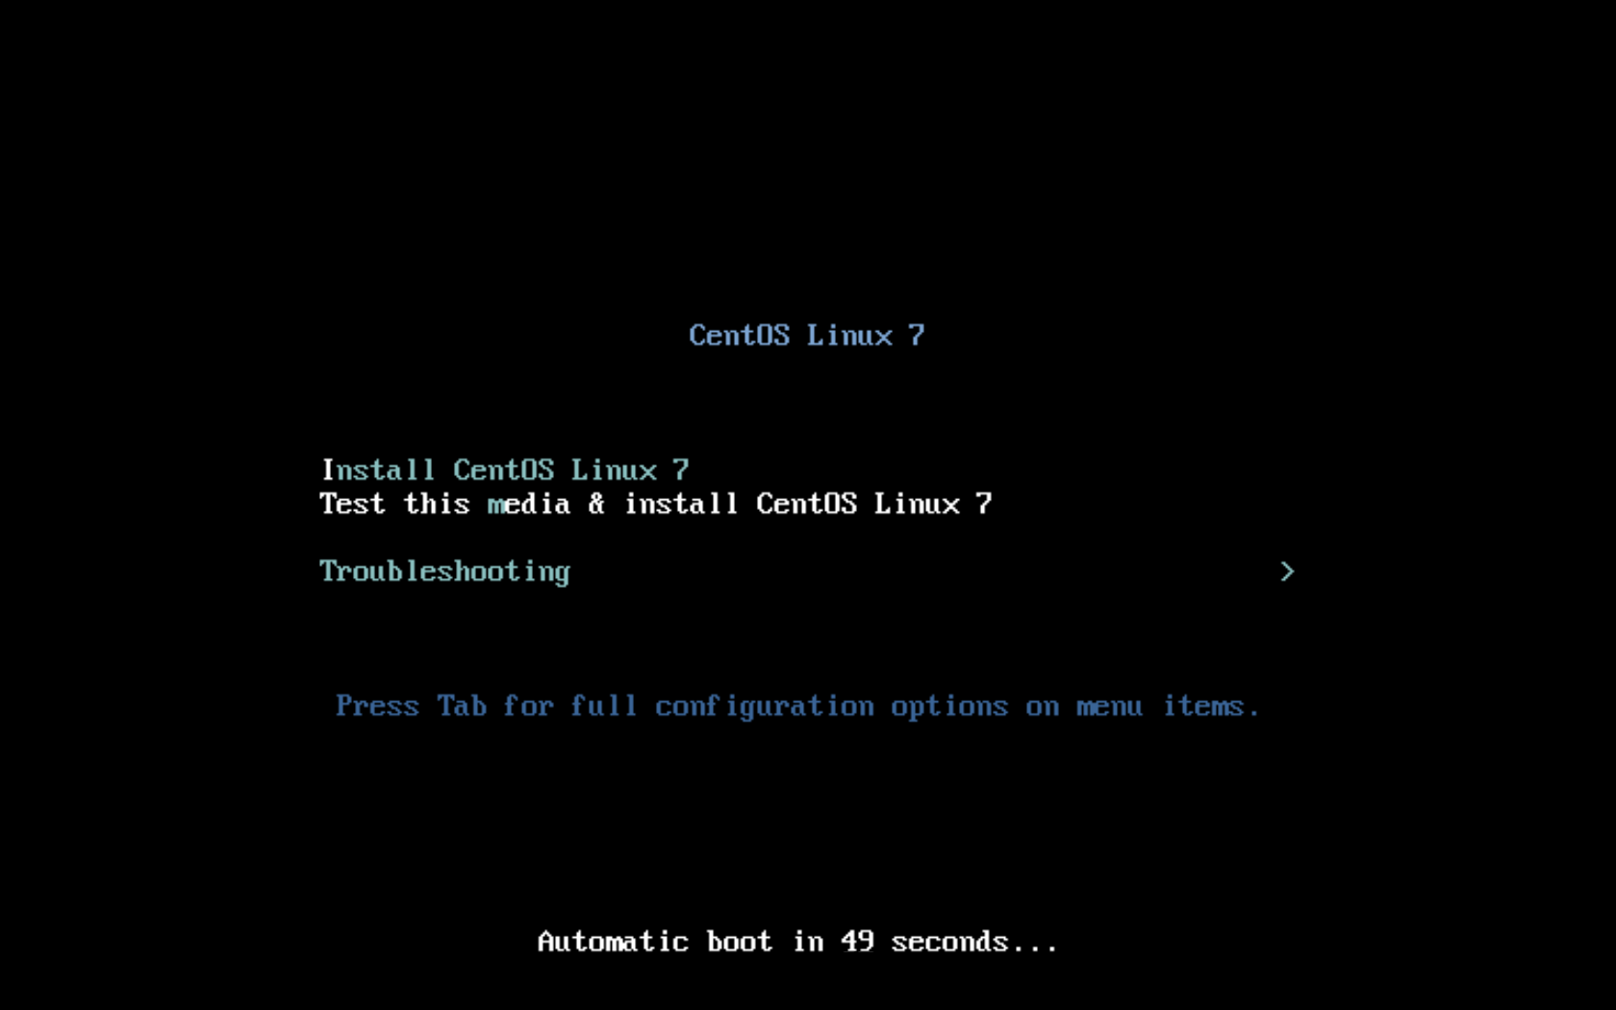

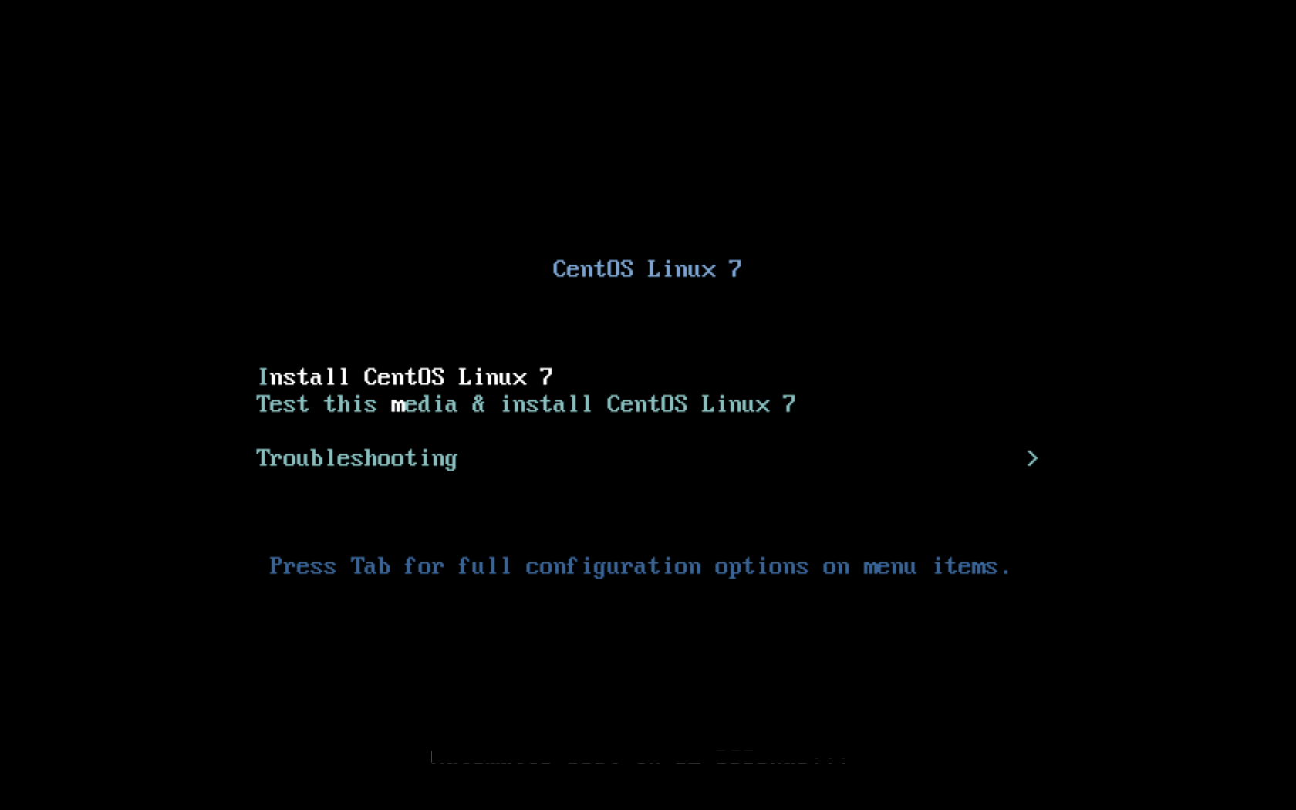

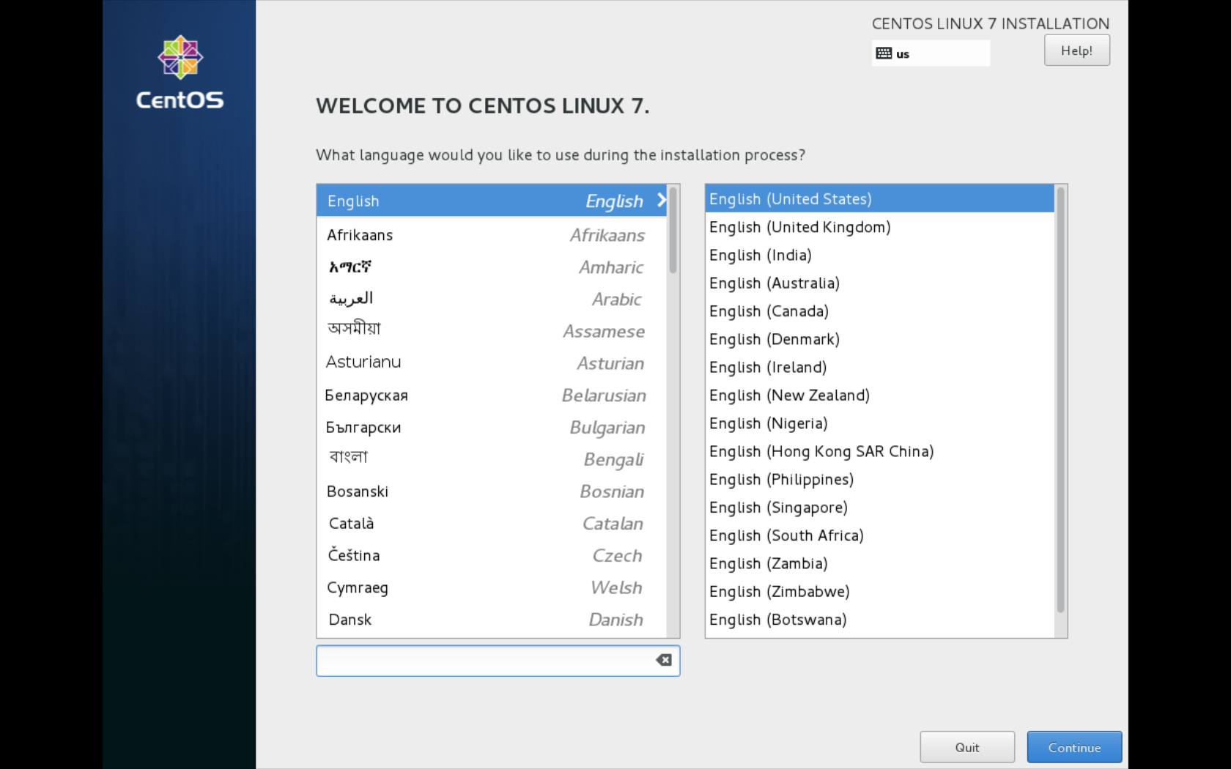

On the main panel, there are buttons to manage:

Locatization:

* Date and Time
* Language
* Keyboard

Software:

* Installation Source
* Software Selection

System:

* Installation Destination
* Network & Host Name
* Kdump
* Security

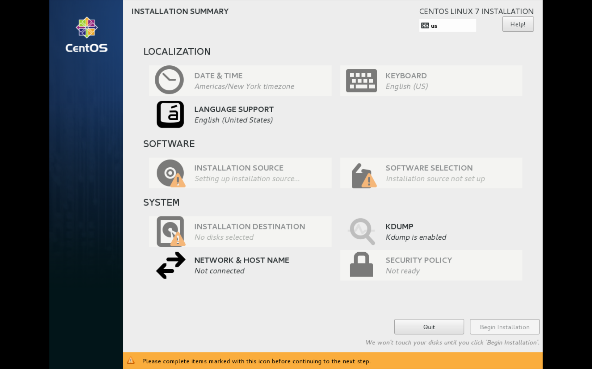

First configure the network.

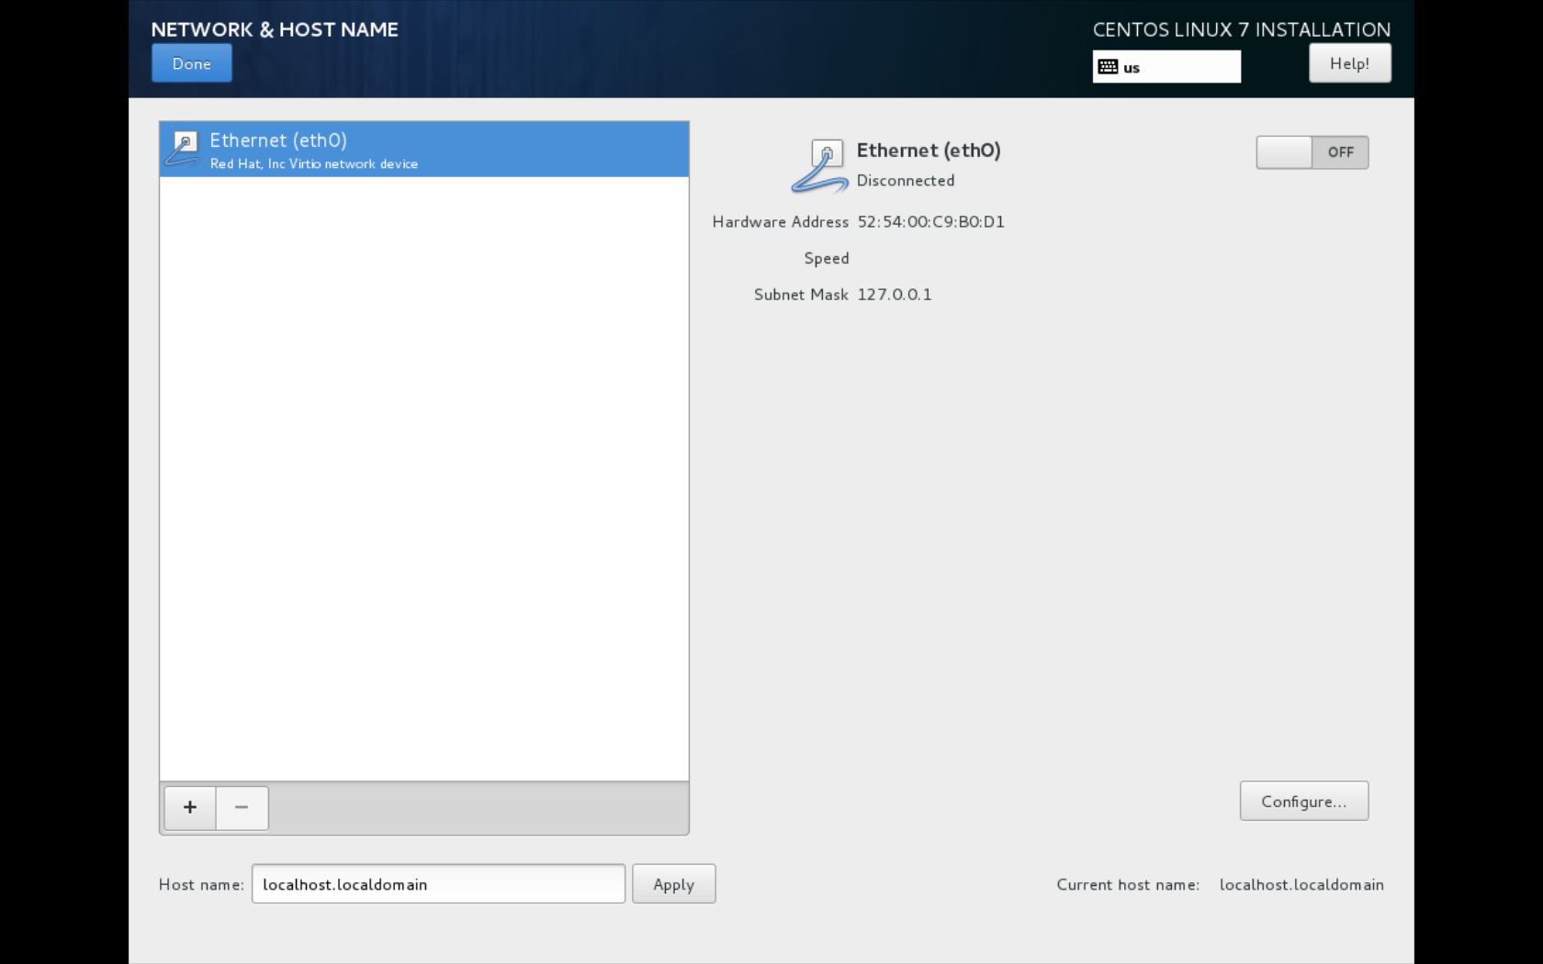

Select: IPv4 Settings:

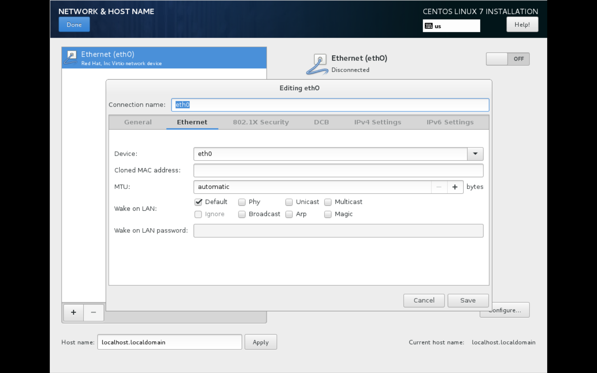

The following screen appears:

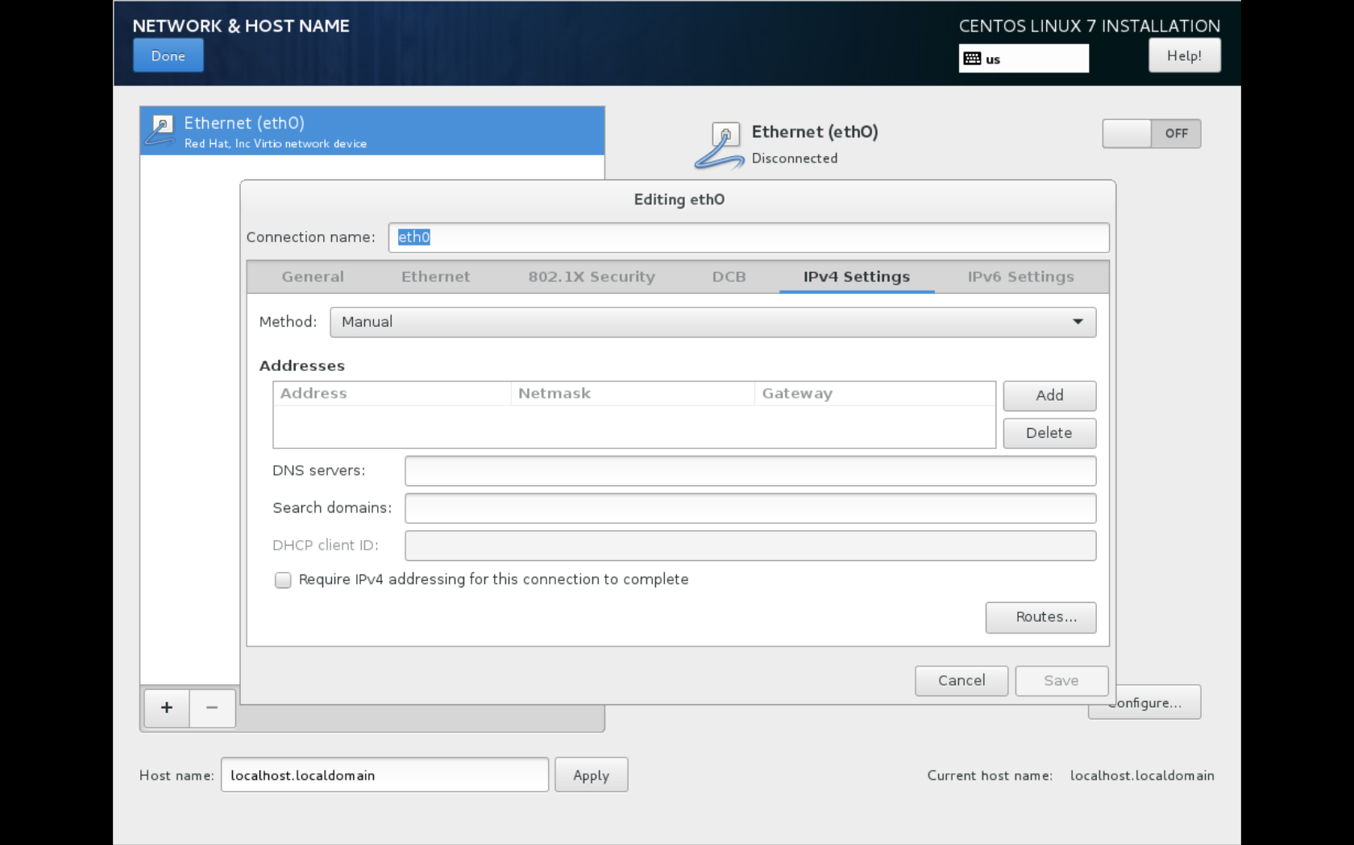

Change method to Manual

Use the add button to configure the static network

and enter the hostname in the lower left box.

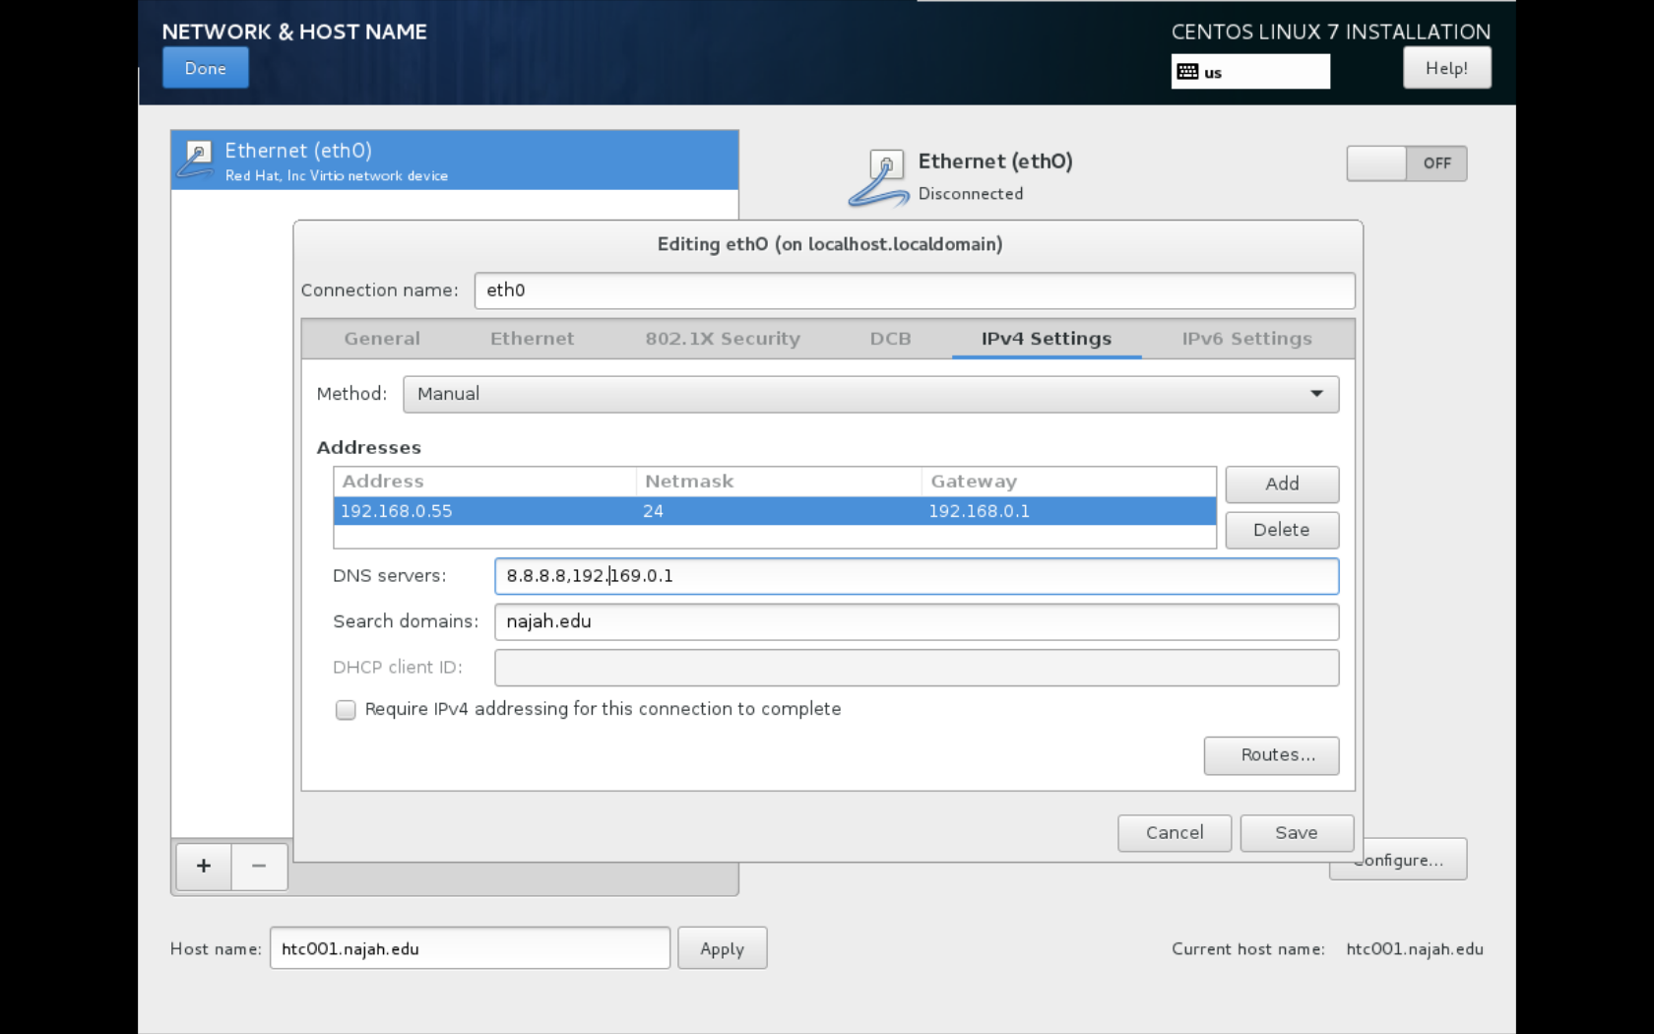

Make sure the upper right box is switched to On. You should now see your network parameters in the right column.

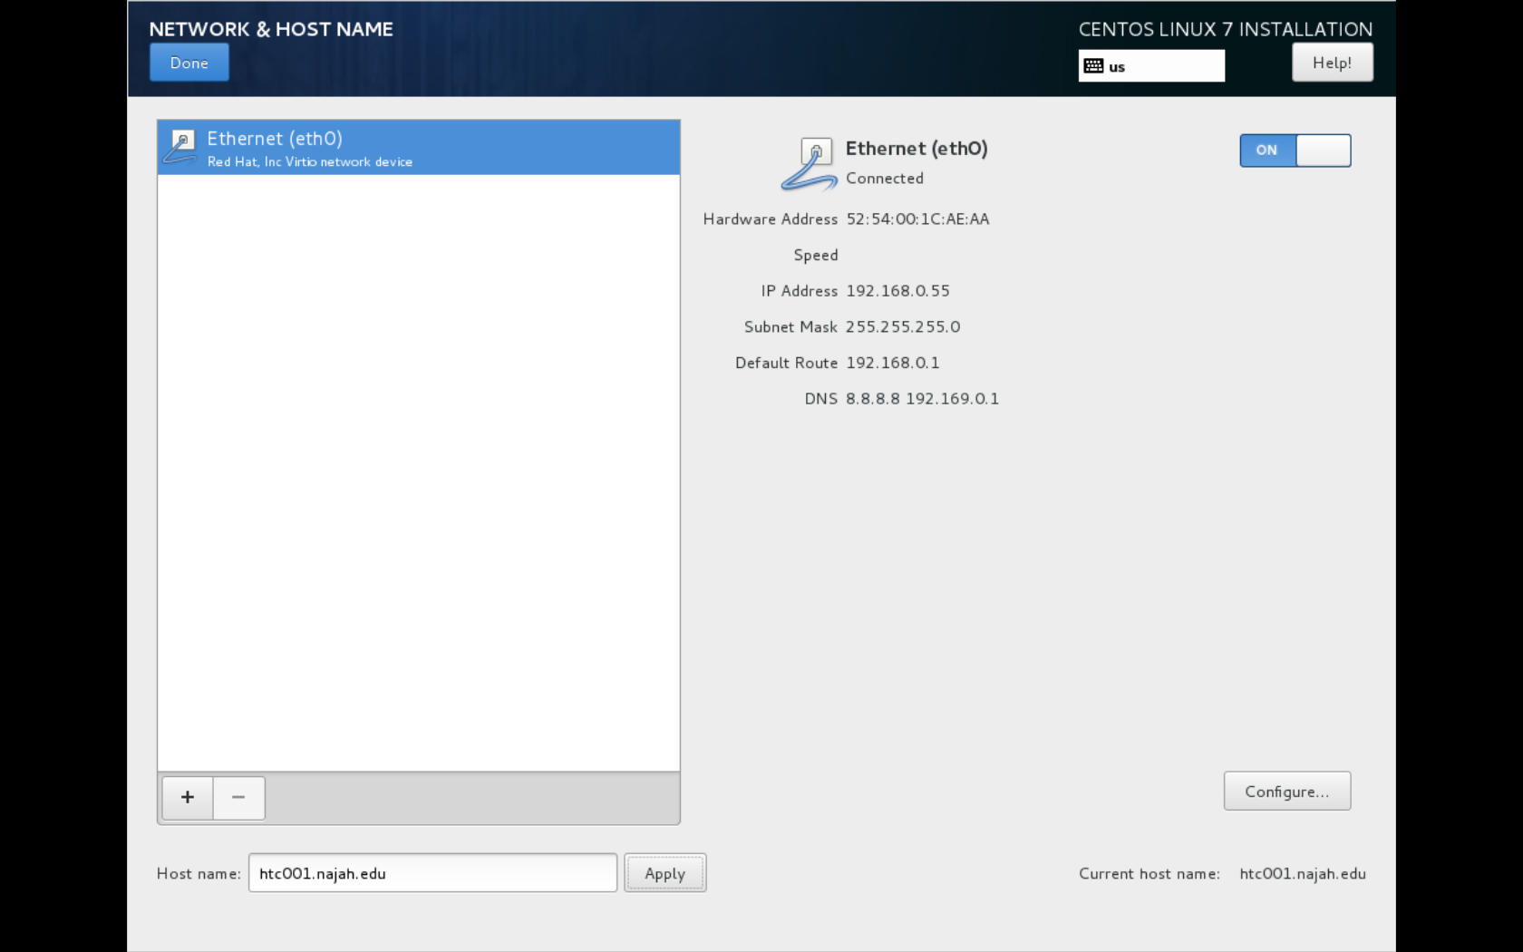

Set the Date & Time: Click on the map near Palestine and you should be able to find Jerusalem. Sorry Nablus is not listed. Make sure Network Time is On. You can adjust the time if you like, but hopefully it will adjust automatically after the operating system is installed.

